Given:
A signal consisting of two tones 300,000 Hz strong and weak with a difference of 1 Hz plus ADC noise
ADC sampling frequency Fd=2500000 Hz
ADC noise spectrum Noise<=-130db
Measurement time Tm = (0.6…1.0) second
Find :
Ton-2 frequency and determine the minimum amplitude that the algorithm still recognizes in noise.
Solution :
The amplitude Ton-1 was taken as 1v. The amplitude of Ton-2 was selected in the course of studying this problem. The noise amplitude was also experimentally determined to be 70μv. Noise with a given amplitude after conversion to the spectrum (0…1250000)Hz turned out to be at a level no higher than -130db. Noise with an amplitude of 70μv was taken for further calculations. A zero padding multiplier of 20 was also adopted. In the process of studying the detection conditions of Ton-2, it turned out that for reliable recognition of two frequencies with a difference Δf, time 1/ Δf is needed. Therefore, for a clear determination of Ton-2 with a difference of Δf=1Hz, a measurement time of 1s is needed. But the experiment was also carried out for a measurement time of less than 1s, while the result of calculating the frequency Ton-2 already gave a noticeable error. Spectra Ton-2 plus noise are given as calculation results. Signature under each spectrum : measurement time ; minimum possible recognition amplitude Ton-2 ; frequency calculation error Ton-2 .
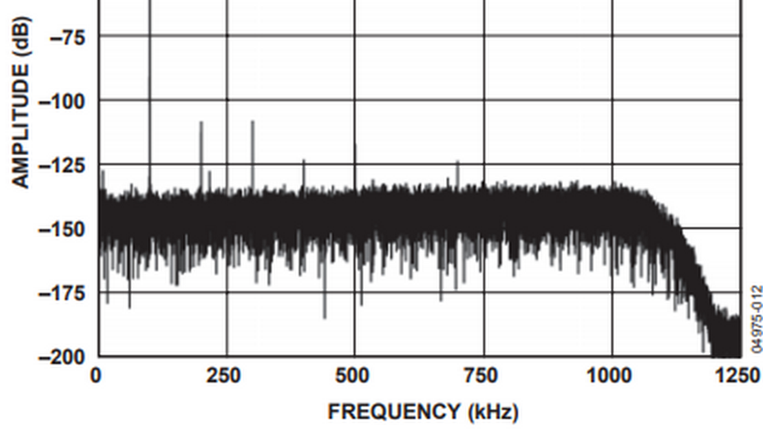
ADC Noise Spectrum
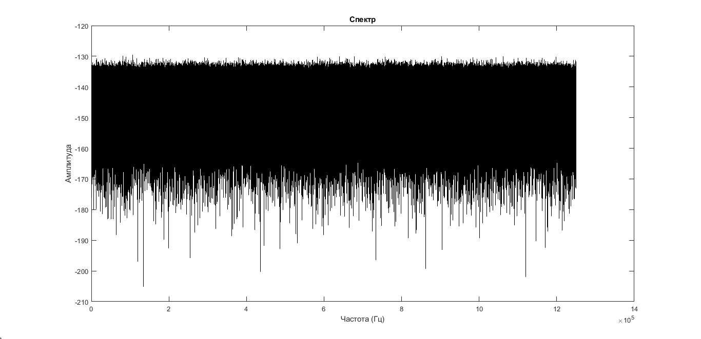 Spectrum of synthetic noise used in calculations

The following are the results of the study from best to worst, then the calculation algorithm:
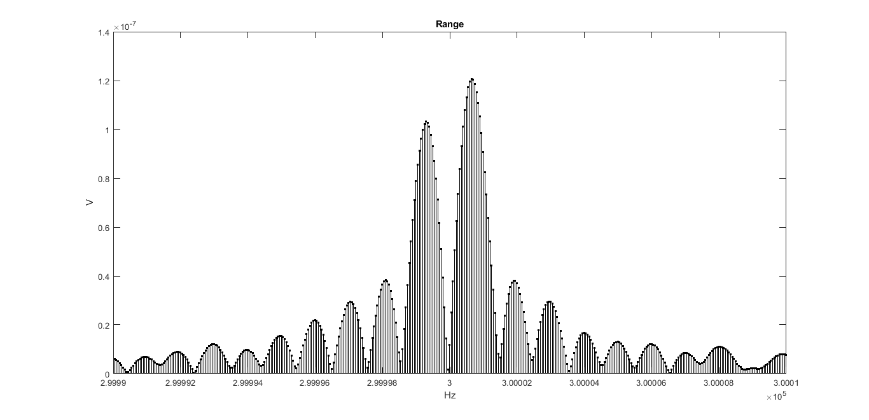
Tm=1s ; A2=0,4μv ; Δf=0,36Hz
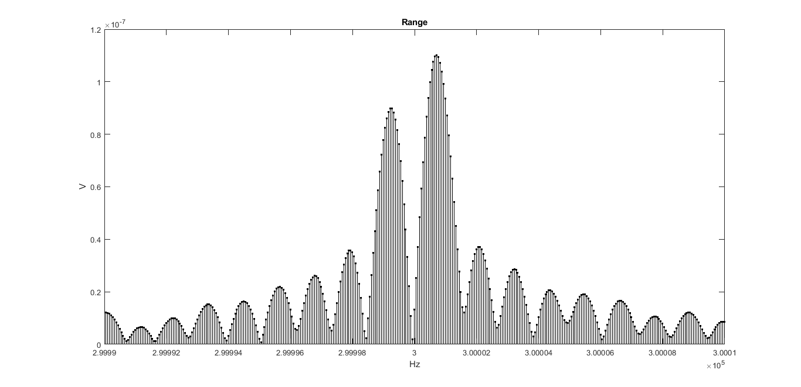
Tm=0,9s ; A2=0,4μv ; Δf=-0,28Hz
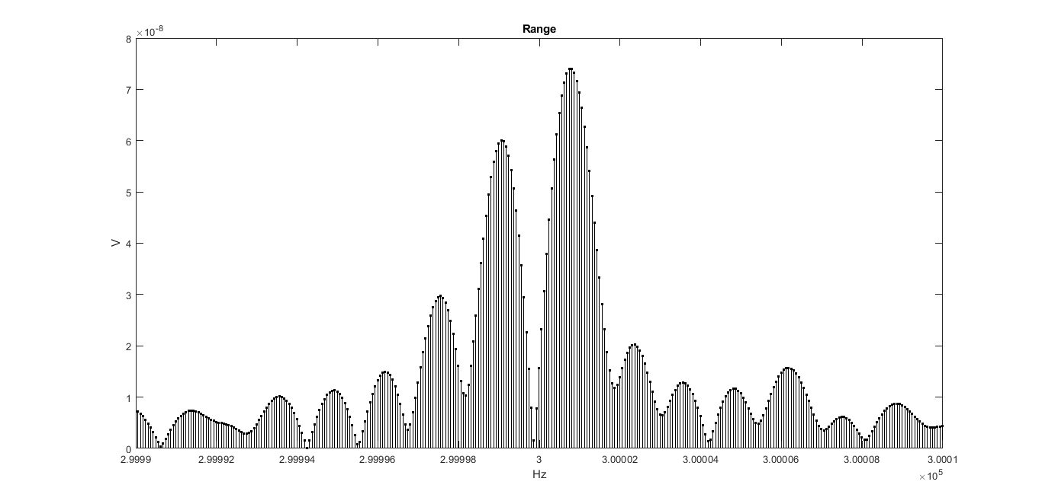
Tm=0,8s ; A2=0,5μv ; Δf=0,19Hz
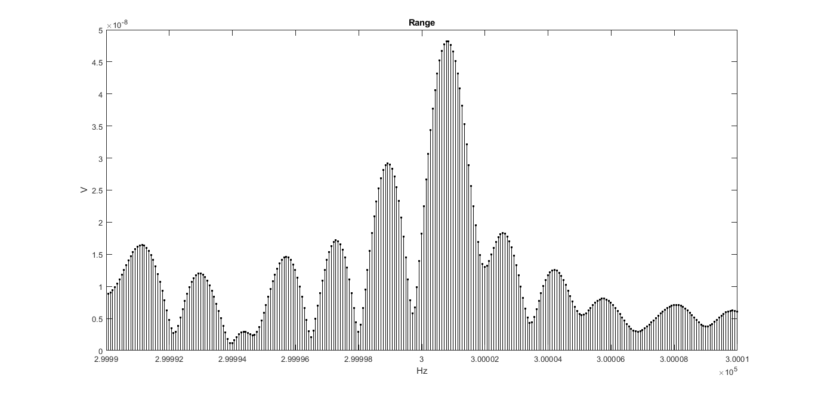
Tm=0,7s ; A2=0,6μv ; Δf=-0,22Hz
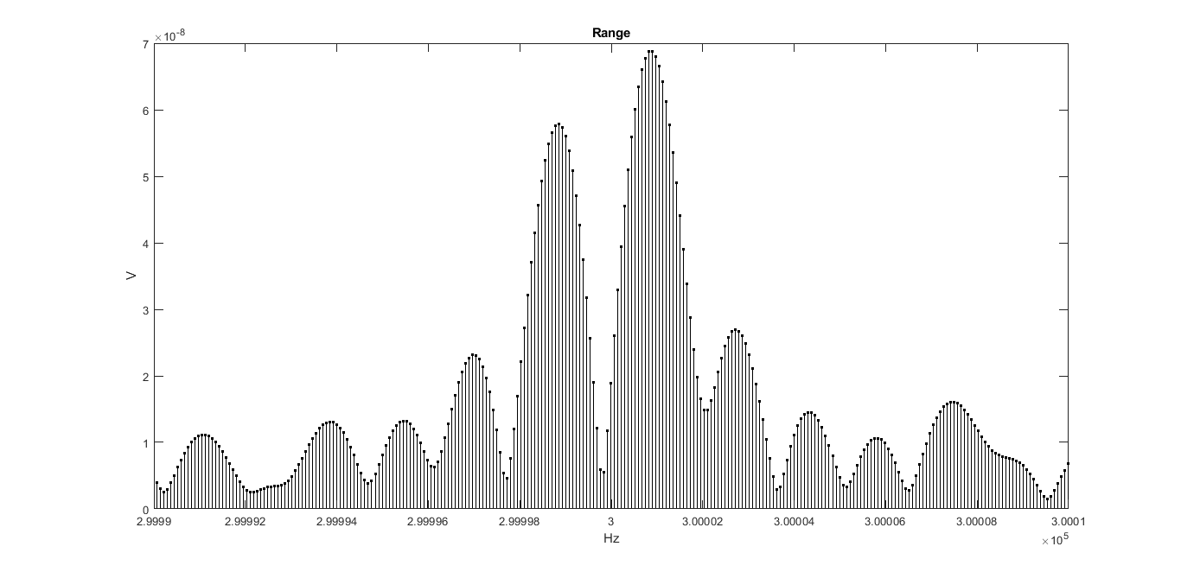
Tm=0,66s ; A2=0,7μv ; Δf=0,1Hz
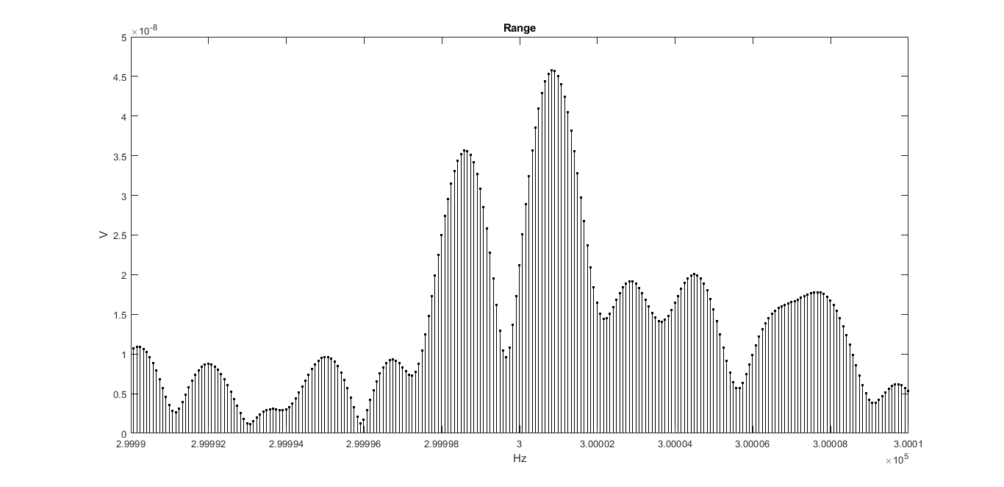Tm=0,6s ; A2=0,8μv ; Δf=0,56Hz

Calculation of frequency, amplitude and phase of Ton-1 and Ton-2
Measured signal , array Signal(i) ; i=(1…N) , transform using fft into an array of the spectrum FftS(j)
Then we look for the maximum in the spectrum
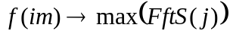 (1)
Where :
im is the index of the maximum amplitude in the spectral array FftS(j)

Frequency calculation Ton-1
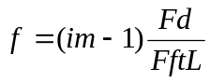 (2)
Where :
Fd - sampling frequency
FftL - number of samples fft
im-1 because j in arrays starts from 1 and not from 0

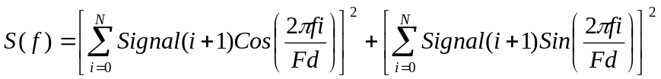 (3)
Where :
N is the number of signal counts during the specified measurement time
i is the number of the measured signal count
Signal(i+1) – readout signal level (i+1)
(i+1) hereinafter because i in arrays starts from 1 and not from 0 , like time
f is the frequency at which the maximum signal amplitude is observed
Fd - ADC sampling frequency

Next, we specify the frequency of the maximum level on the reading (im)
We are looking for the maximum of the function (3) on the interval :

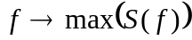 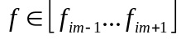 (4)

The frequency found by the maximization algorithm with a predetermined accuracy of 0.0001Hz is taken equal to the frequency Ton-1 . Next, we calculate the missing amplitude and phase Ton-1 using the least square error method of the difference vector .
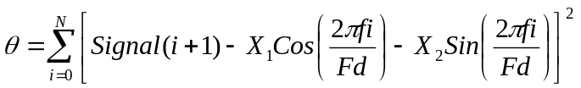 (5)
where : X1 and X2 are the coefficients of the vector containing the amplitude and phase of Ton-1

After opening the brackets and simplifying, we obtain a formula with two unknowns X1 and X2 , which we differentiate separately with respect to X1 and X2 . From here we get two formulas for equating to zero (search for an extremum), which in turn form a system of linear equations with two unknowns X1 and X2.

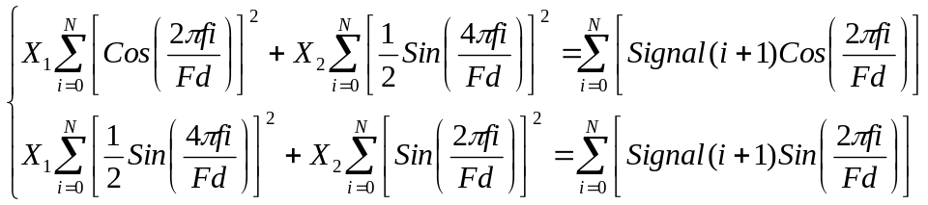 (6)

We solve the system of equations in a matrix way, from where the amplitude Ton-1 is determined minus the average spectral amplitude (noise):

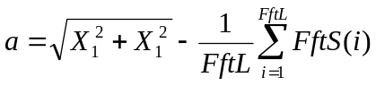 (7)

Phase Ton-1 is in the range of 0…360 degrees, so a special formula is applied:
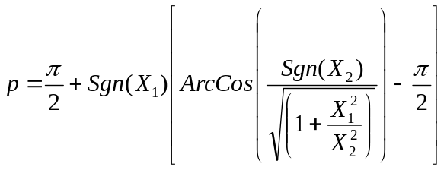 (8)
The subtraction function is now defined in two ways :

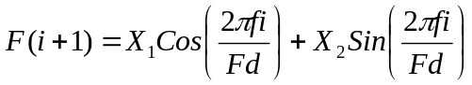 (9)

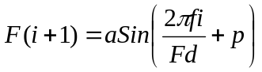 (10)

Formula (10) was chosen for the deduction, since it takes into account noise in its amplitude (see formula 7) . Next, we subtract the found function from the signal and get a new signal , in which there will no longer be a Ton-1 component:

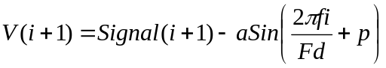 (11)

Now the signal V(i + 1) is converted using fft into a spectrum and using formulas (1) and (2) we find the frequency Ton-2
If you also need an amplitude with a phase of Ton-2, then we calculate them using the already given formulas (3 ... 8) , where instead of Signal (i + 1) we substitute V (i + 1)

